Body Use of Grid component

The Material Design responsive layout grid adapts to screen size and orientation, ensuring consistency across layouts.

Basically if we use grid then depending on screen size it will adjust content

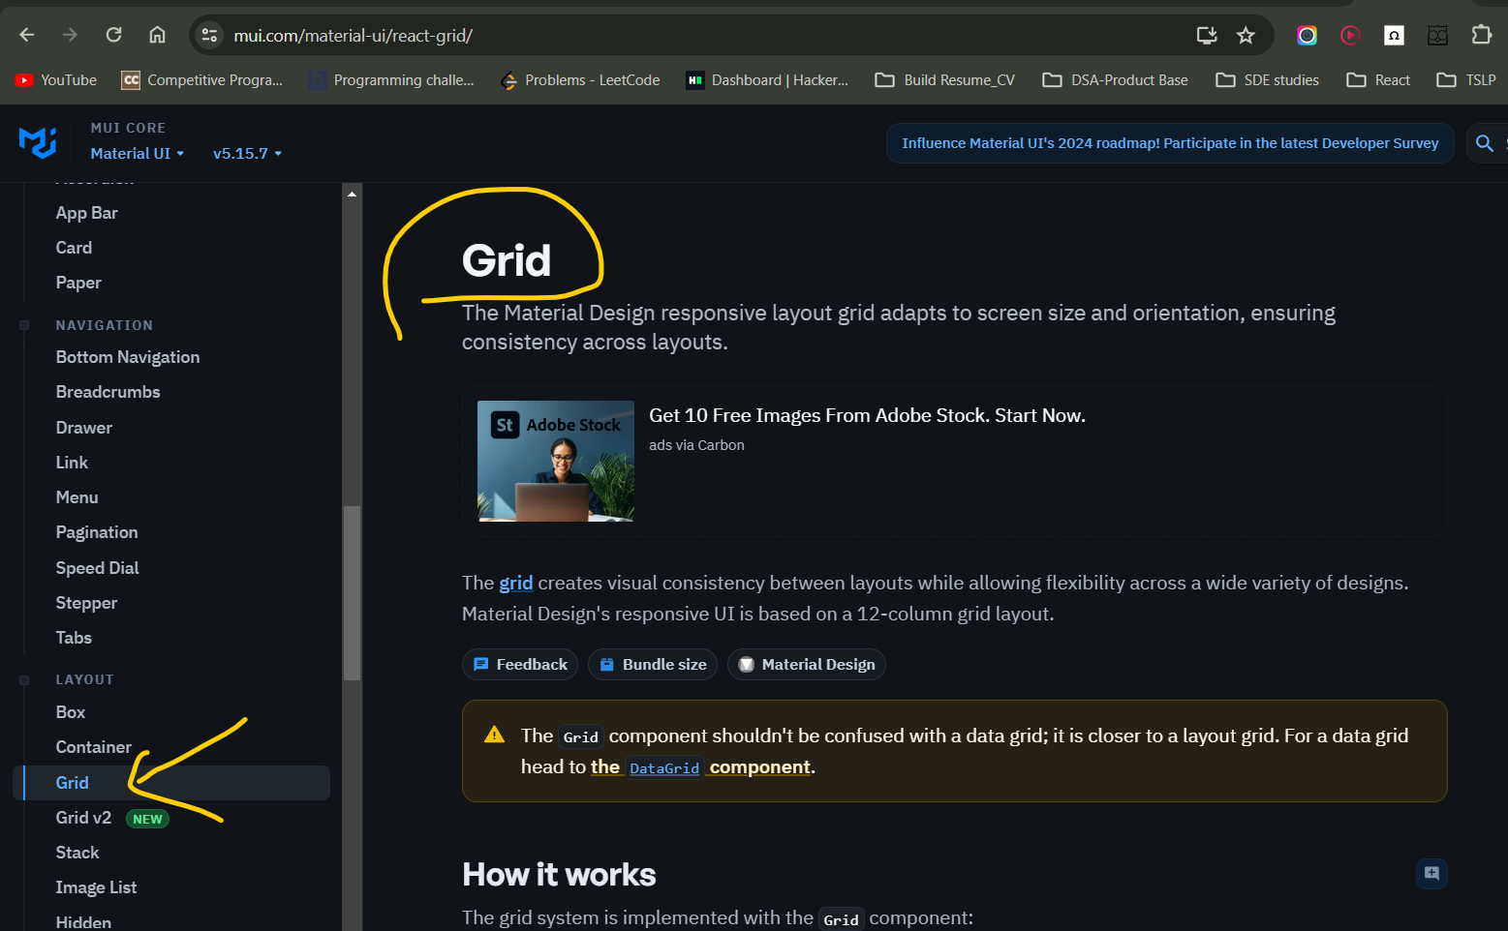

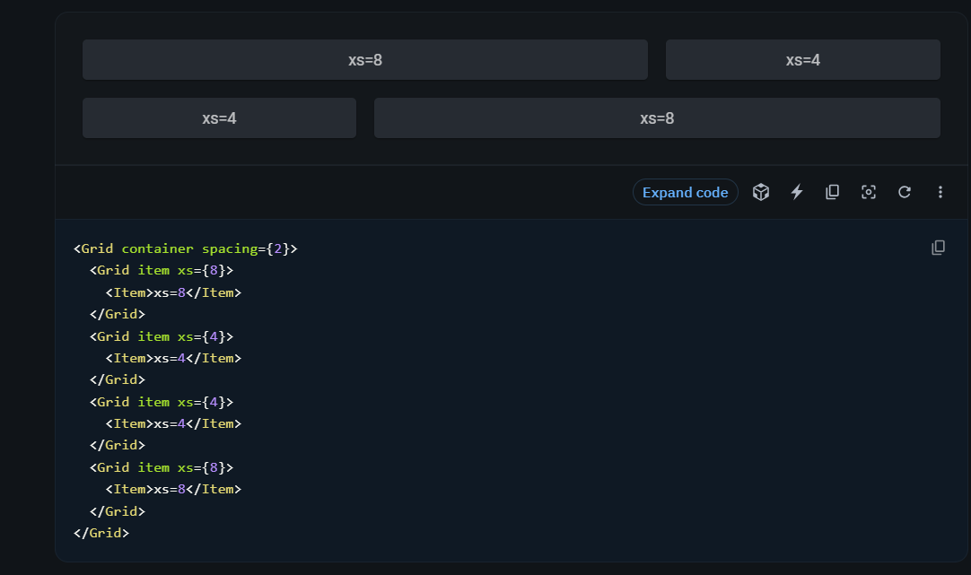

<Grid container spacing={3}> <Grid>

container spacing={3} = is the gap between grids

App.js

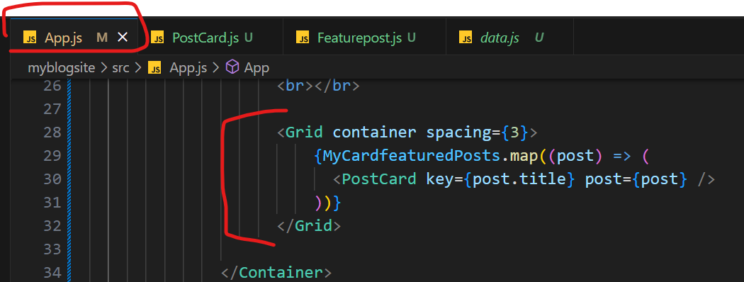

Data.js

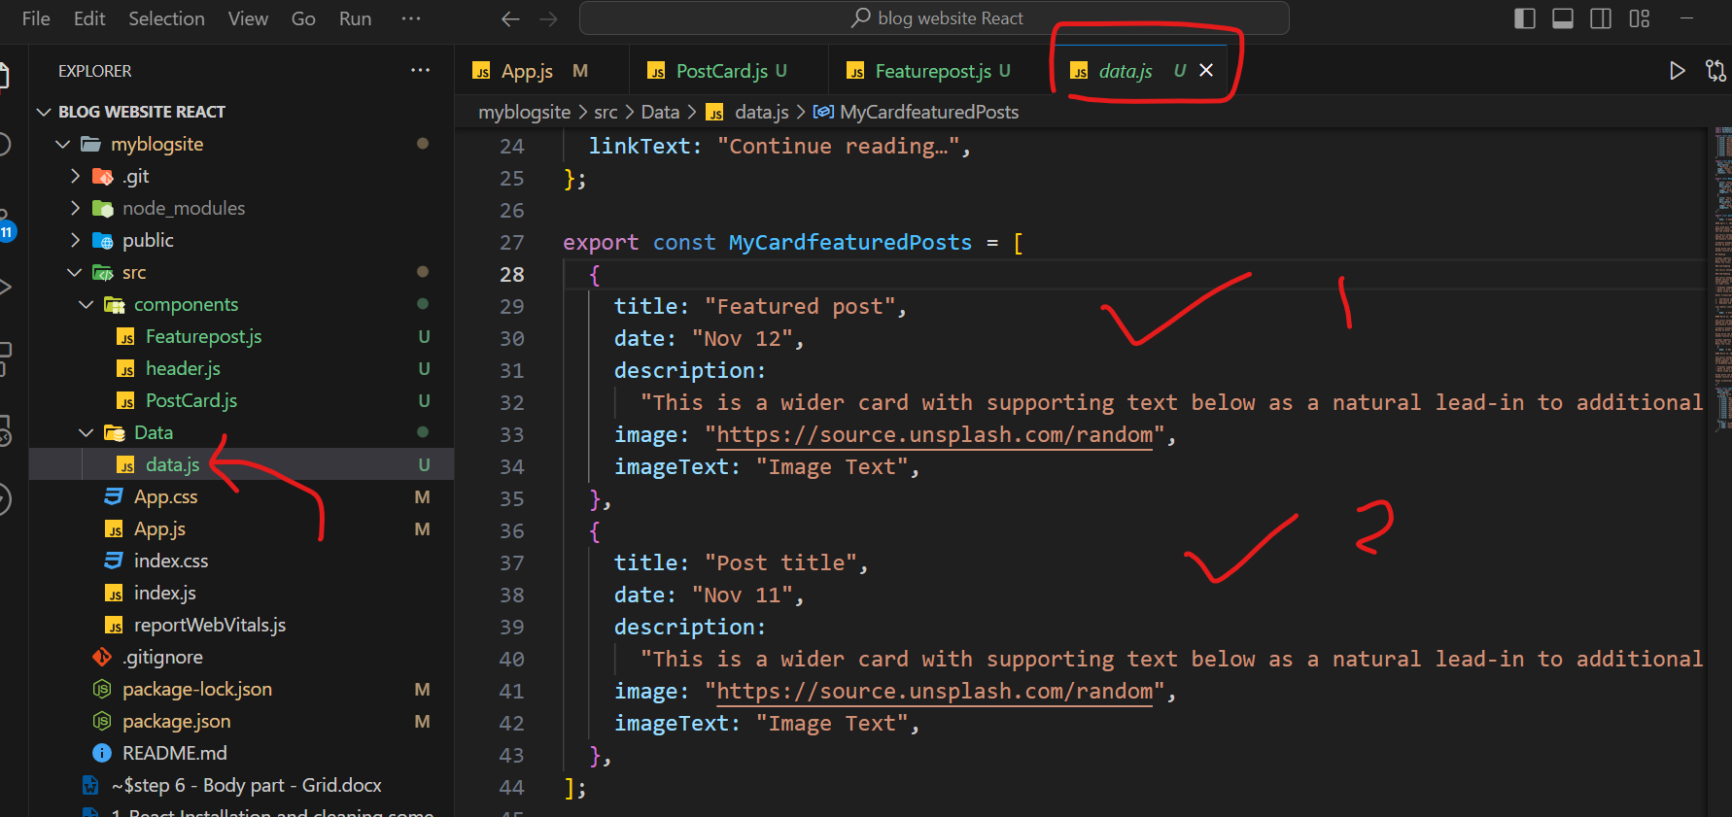

PostCard.js

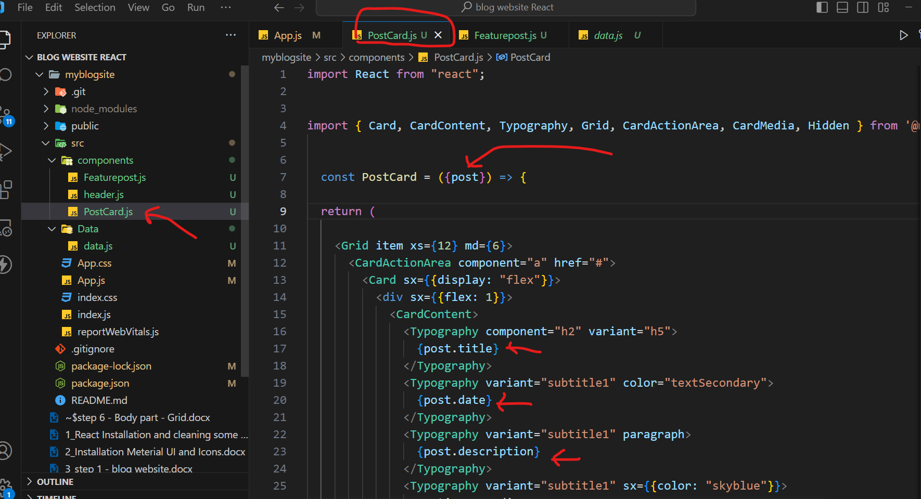

O/P ( Check in the Browser )

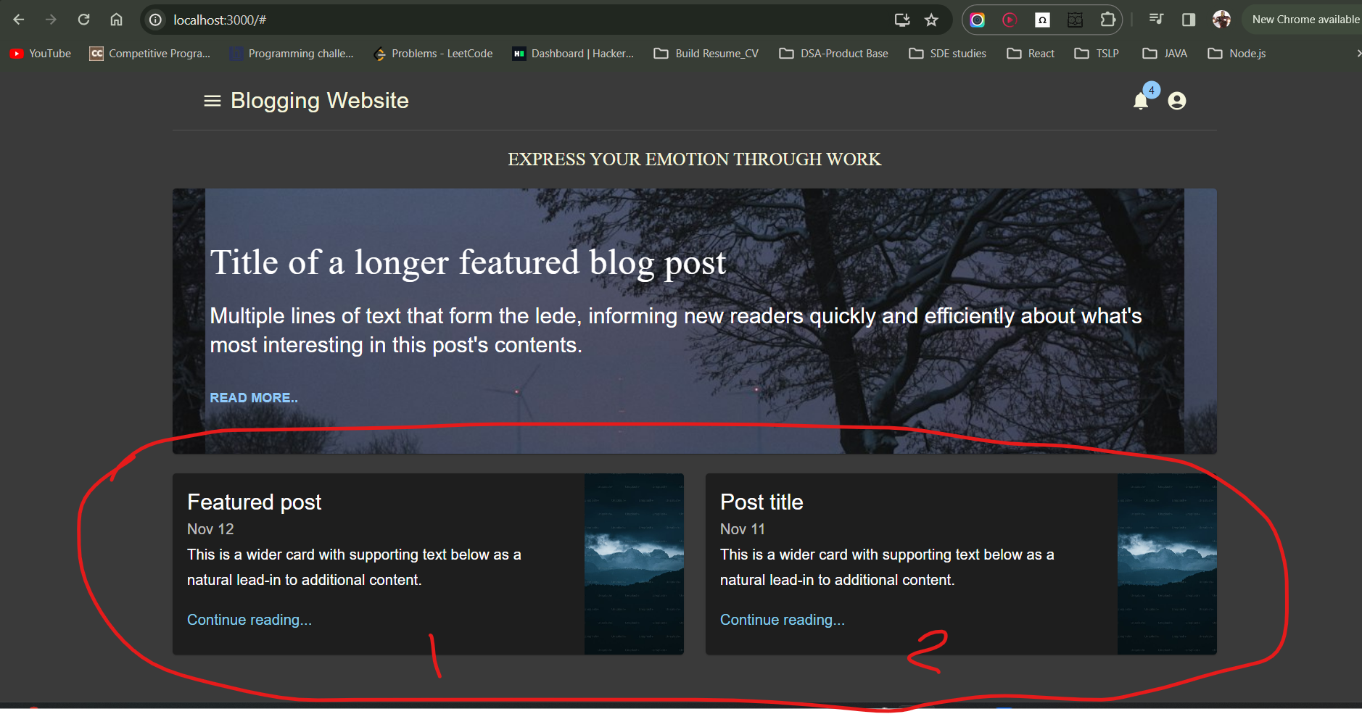

What we are doing here?

We could direct write Title, Date, and Description in PostCard.js

But if there are 5 or 6 or many cards to be display in one row then writing Title, Date, and Description for each card would make a huge line on codes in PostCard.js and confusing also.

That’s why we are looping through all card content using map

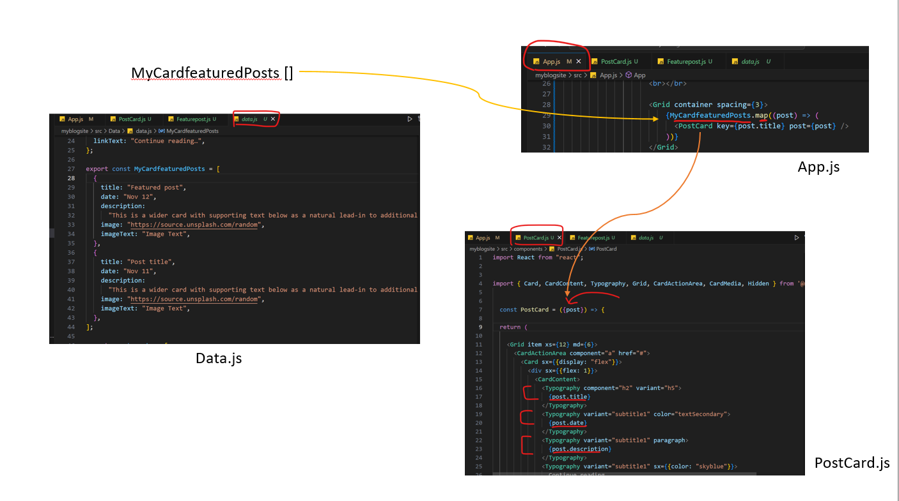

<Grid item xs={12} md={6}> <Grid>

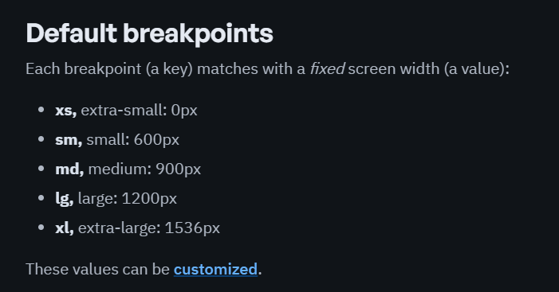

Some grid concept



O/p

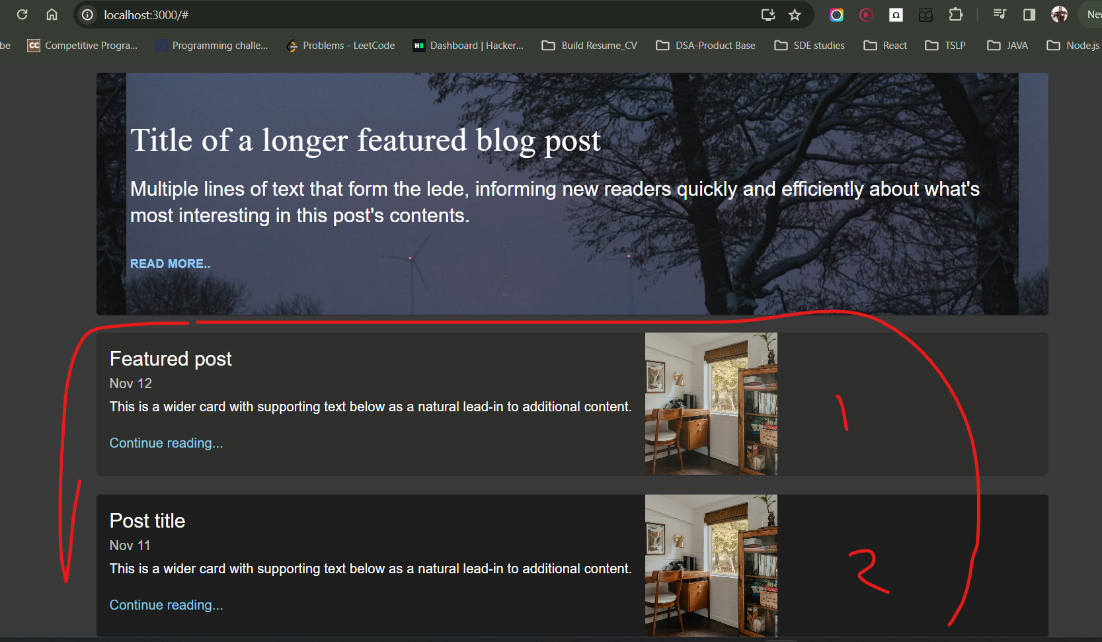

<Grid item xs={12} sm={6} >

Sm is small 600 px (if the content has to be fit in small the sm ) else use md,xl etc.

Sm is break point means ; content inside <grid> will be responsive when resolution will be < 600 px ( less than 600 pixel )

Why 6 ?

* In react Grid, a row is 12 so as we need 2 cards before geeting sm ( small responsive ) so 6 for each card

Resolution is 600

Not responsive yet

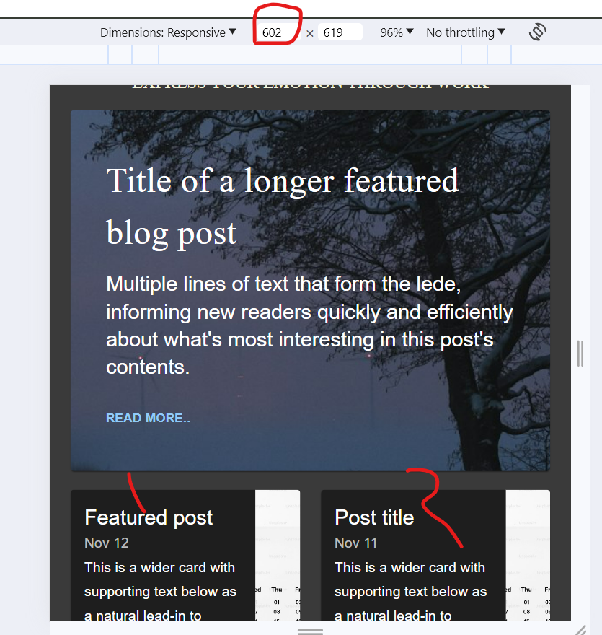

Resolution is 599

responsive yet

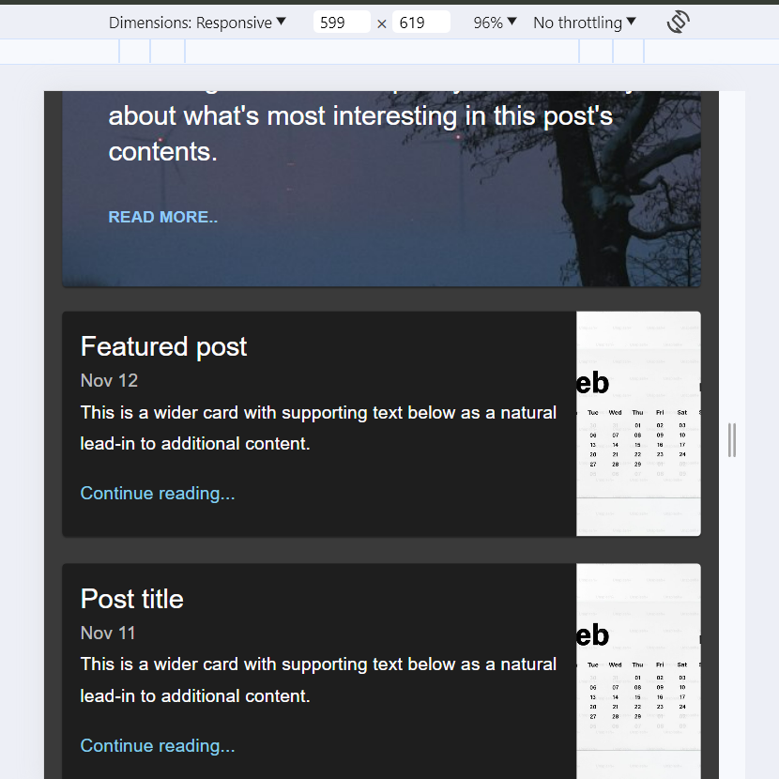

**Hidden tag Feature in MIUI**

Hidden tag works with

mdDown = md means 900 px.

So when screen size >= 900 inside <hidden> content will be visible.

when screen size < 900 inside <hidden> content will be not visible.

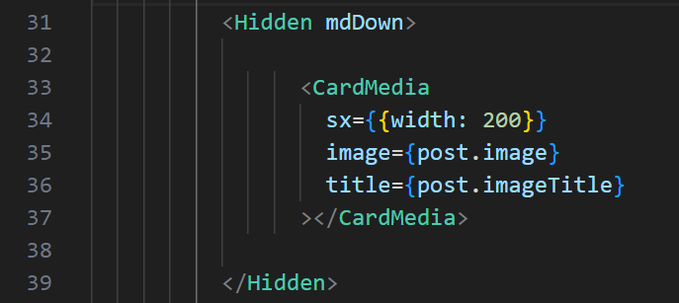

Check in the Browser

Resolution is 899 < 900 (md). So content will not be visible

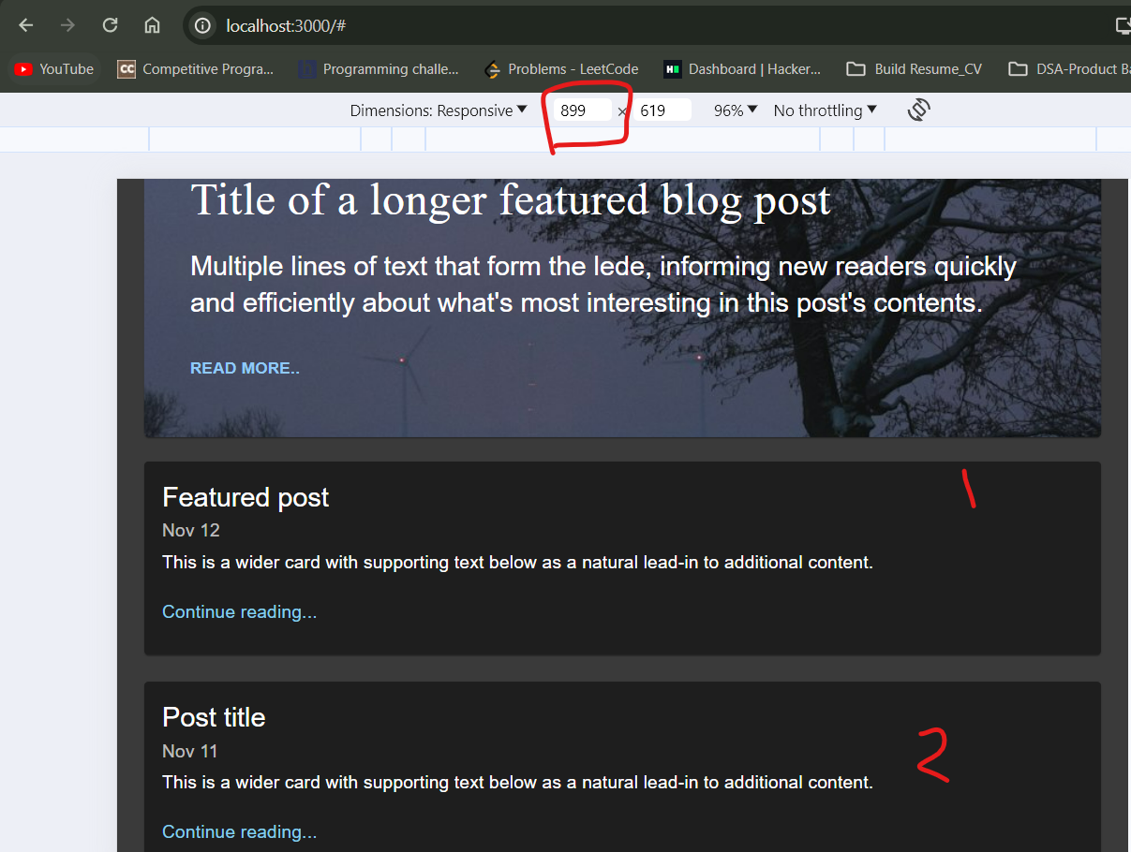

Resolution is 901 > 900 (md). So content will be visible

